Jarron Bailey

Homework 9

Date: April 8th, 2019

**Test 1: Enter no coins:**

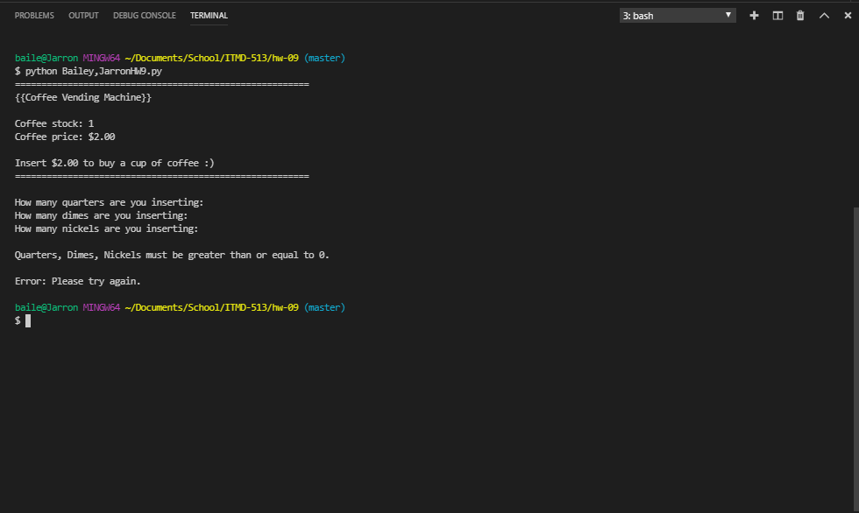

**Test 2: Valid Dime; Invalid Quarters and Nickels**

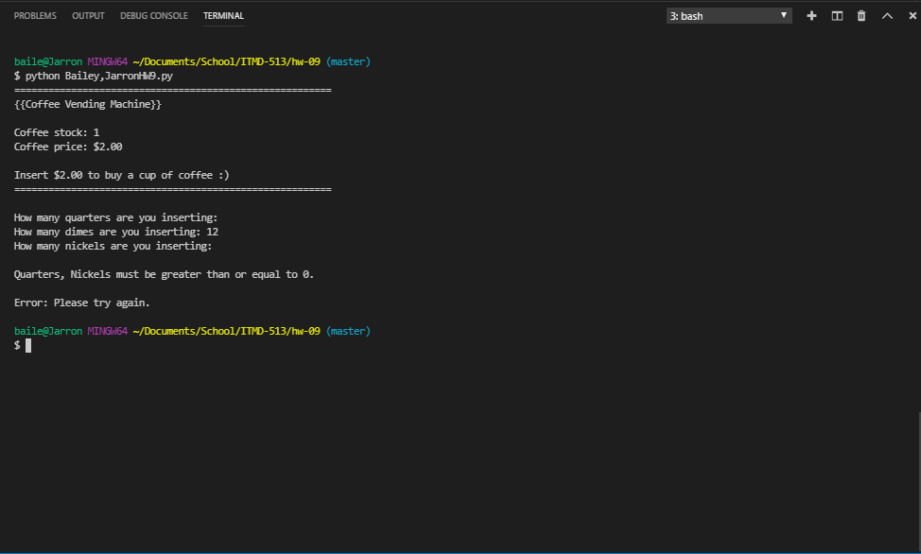

**Test 3: Quarter: Int; Dime: Empty; Nickels: Str**

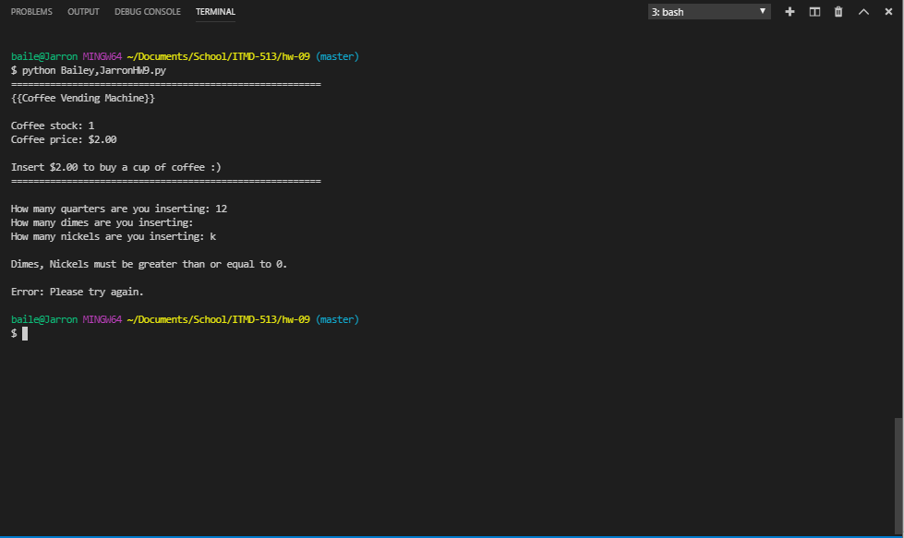

**Test 4: Quarters: Float; Dimes and Nickels: Int**

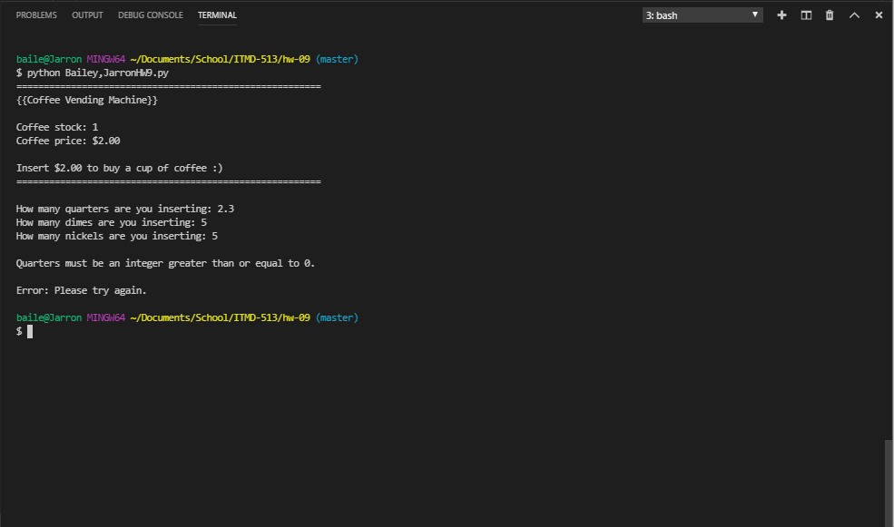

**Test 5: Valid coin inputs but not enough money**

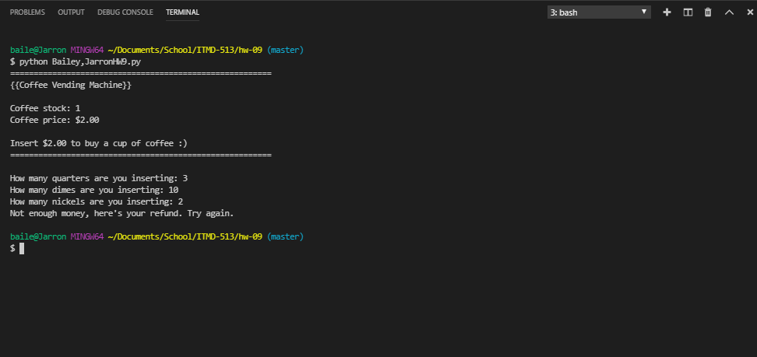

**Test 6: Valid inputs, not enough money and out of stock**



**Test 6: Valid inputs, nough money and out of stock**

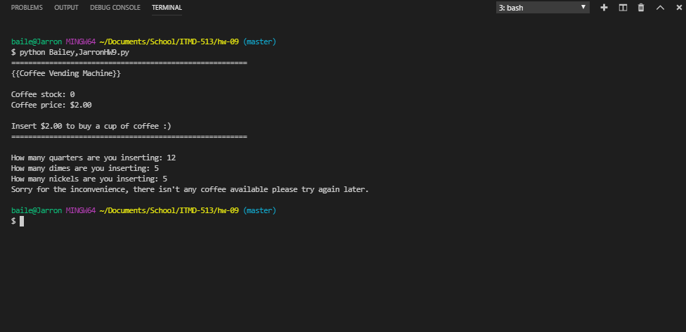

**Test 7: Valid inputs, too much money and stock**

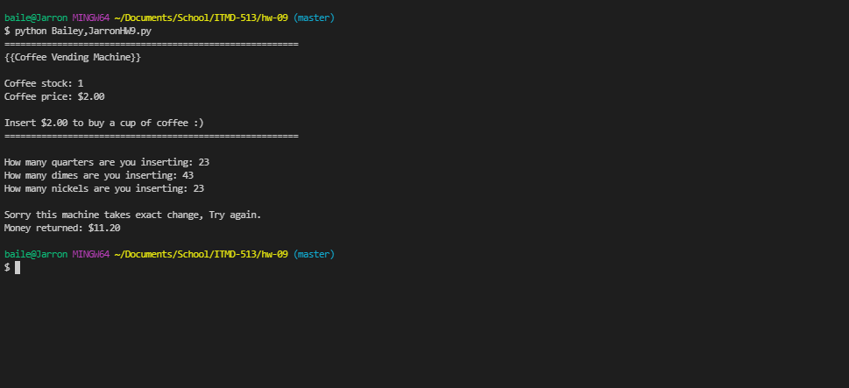

**Test 8: Valid inputs, enough money and exact price**

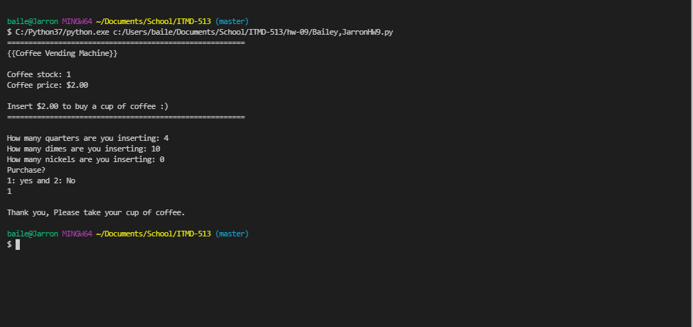

**Test 9: Invoking refund**

